**CougSat Simulation Software**

**Solution Approach**



**Mentor**

Aaron Crandall

**Team Viking**

Courtney Snyder

Angie Park

Solomon Egwuonwu

Edward Kuo

Course: CptS 421 Software Design Project I

Instructor: Aaron Crandall

**TABLE OF CONTENTS**

**I.** **Introduction 2**

**II. System Overview 2**

**III.** **Architecture Design 3**

III.1. Overview 3

III.2. Subsystem Decomposition 3

*III.2.1.* *System Tool Kit 4*

*III.2.2.* *COLLADA 5*

*III.2.3. State Machines 6*

**IV.** **Data design 12**

**V. User Interface Design 13**

**VI.** **Summary of the State of This Project 13**

**VII.** **Future Work for This Semester 14**

**VIII.** **Glossary 15**

**IX.** **References 16**

# 

# **I. Introduction**

The purpose of this document is to outline the work we have done this semester and the work to be done to complete our beta prototype by April.

Our client, the club Cougs in Space of Washington State University in Pullman, wants to know that their cubesat, CougSat I, will successfully launch and orbit. To help them feel more confident and help them further develop their design, we will build a testing suite for them. This testing suite will go through all stages of both the launch and orbit to determine if anything could fail and identify possible causes of failure. This will enable the club to create a more robust system and more likely make for a successful mission.

Development of the testing suite will be broken up into two phases, the alpha prototype and the beta prototype. Last semester, we completed the alpha prototype, which is a state machine that exhibits at all of the top-level behaviors that CougSat I will have. This semester, we have been working on the beta prototype, which integrates the state machine into the physics engine, STK, using a digital model of the satellite built in Blender.

The rest of the document contains sections for system overview, architecture design, user interface design, the state of the project, and future work for the project this semester.

# **II. System Overview**

We were instructed by our mentor to construct a testing suite of CougSat I to demonstrate its behavior from launch to orbit. During last semester, we designed a general state machine to understand how the cubesat itself works and to see the high level scope of how the satellite behaves as a whole. Then, we broke up the satellite into the individual circuit boards: Attitude, Communications, Main, Payload, and Power.

The simulation is constructed in STK and it is focused on the numeric results for the successful orbiting around the Earth. Finding the best orbit that allows the longest amount of communication time with ground station(s), how to generate the most solar power, what languages the script should use, and questions like those have been the main topics to implement the simulation for the last two and a half months. From now on, integrating the ideal behaviors into the satellite on the simulation will be the top priority of this project.

# 

# **III. Architecture Design**

## **III.1. Overview**

With the general design we have, we focused on implementing the simulation. To fully implement the simulation, we first made its bare-bones frame using default models for the satellite and ground stations.The first candidate of the ground station was the Echostar Spokane Station which was from the facilities database of STK. The current candidates are on the five cities with Washington State University campuses: Everett, Pullman, Spokane, Tri Cities, and Vancouver.

The model of satellite has been through a number of changes as well. STK provides the sample model of 1U cubesat. After getting information from the team lead of the power team, we put four solar panels with a total of 28.3% efficiency on the satellite. The four solar panels generate an average total of 2.5 Watts of power. The satellite needs to be improved to reach 4 or ideally 5 Watts to charge the battery while it uses the power in case the satellite does not get light from the sun for an extended period of time during the orbit. Furthermore, the orbit of the satellite does not cover the ground stations we have now, which is another thing to be improved before the beta prototype is completed.

The second phase of the project is to make the basic models contain the attributes. Our alpha prototype, which was developing the state machines of the satellite’s boards, provides us with information about the behaviors of the individual circuit boards within the satellite. The behaviors that will integrate into the model of CougSat I are all methods of the state machines of each boards and include commands like; launching, detumbling, booting, and processing.

Additionally, the interaction between the satellite and the ground station(s) will be critical. They should accurately model and represent the communication components like antenna, receiver, and transmitter.

## **III.2. Subsystem Decomposition**

We are using AGI’s STK as our physics engine and base for our simulation. STK allows for state machine integration and models of satellites and ground stations, as well as simulation of communications to and from the satellite.

We are modelling the frame of CougSat I using a COLLADA dae file; the file contains the cube and the solar panels. In order to manage and edit the dae files, we used Blender, a popular open source 3D modeling software.

We broke our state machine into five main subsystems because there are currently five circuit boards on CougSat I and we wanted to illustrate both how they work individually and how they work together. The Attitude, Communication, Main, Payload, and Power subsystems illustrate individual circuit board behaviors. Note that the main board is connected to each of the other circuit boards and the other boards are not connected to each other.

Based on the following descriptions of the subsystems, we will achieve the goal to make the final model of the satellite.

### **III.2.1 Systems Tool Kit (STK)**

#### **a) Description**

STK is a physics engine that allows us to run simulations of a satellite launch. STK is a valuable tool because it will allow us to collect data and simulate the behavior of the CougSat I without launching the satellite into orbit. This will help us find the ideal orbit and ground stations to use for the actual mission. We are using a python file to automate the simulation and creation of the satellite and ground stations.

#### **b) Concepts and Algorithms Generated**

For our simulation file, we will be adding multiple ground stations at minimum all of the WSU campuses and multiple satellites with different orbit patterns. The solar panels on each satellite will behave closely to the ideal behaviors of the solar panels on the CougSat I to generate the most energy from the sun. Using STK’s built in tools, we will be able to easily get data and improve our simulation. Some of these include how much power we are getting from the solar panels and how long each satellite is able to communicate with each ground station over a duration of time.

#### **c) Interface Description**

Services Provided:

1. Satellite Modeling

Service provided to: Entire satellite

Description: STK allows for physical modelling of satellites and their antennas, receivers, and transmitters. Users are able to specify launch position, size, weight, and shape of satellite as well as size, range, and frequency of antennas, receivers, and transmitters.

2. Ground Station Modeling

Service provided to: Ground station(s)

Description: STK allows for physical modelling of ground stations and their antennas, receivers, and transmitters. Users are able to specify geographical coordinates of ground stations as well as size, range, and frequency of antennas, receivers, and transmitters.

3. State Machine Integration

Service provided to: Entire satellite

Description: STK allows us to integrate subsystems’ state machines into the satellite as its behaviors. Since the state machines instruct how CougSat I would behave from launch to orbit in space, the satellite after the integration with them will be completed.

4. Launch

Service provided to: Entire satellite

Description: STK handles the basic launch of the satellite. Our project is mostly concerned with the results of the launch rather than the process of it, because NASA is responsible for the launch of CougSat I, but the club is responsible for activating the satellite after the fact.

5. Orbit

Service provided to: Entire satellite

Description: Users can specify the height, degree, and wave-type of the satellite’s orbit. They can also choose launch coordinates that are non-equatorial if needed.

6. Communication Windows

Service provided to: Entire satellite and Ground station(s)

Description: Users can analyze transmission windows between their satellite and ground stations. This can help them determine which ground station(s) or locations for ground stations are ideal for maximal communication.

Services Required:

Battery level and power mode are required from the Power subsystem. Communication-level commands and inner transmission are required from the Communication subsystem.

### **III.2.2 COLLADA**

#### **a) Description**

COLLADA is an interchange file for 3D design with an extension of .dae. The DAE file is one of the file formats that represent the satellite’s model. It is based on XML schema, and users trying to modify it can use 3D modeling suite. For example, we tried with Google’s Sketchup first and ended up using Blender which is free and open source.

#### **b) Concepts and Algorithms Generated**

Using Blender, the COLLADA file has the shape of the cube. CougSat I is 1U cubesat, so the 3D model of the file is composed of one cube. The cube could contain 4 planes that would signify the solar panels in the simulator like STK. Attaching extra attributes can be done by modifying the XML compositions. The XML file would have nodes for each planes on the cube. We could modify the file to make the satellite contain articulations, sensors, effects, pointable elements (radio dishes, camera, etc.), non-obscuring materials, and solar panels. So far, we have achieved the goal to use Solar Panel Tool with solar panels on COLLADA file. The syntax of solar panel groups identifies it is the technique of AGI and the efficiency of the solar panel, which we use as 28.3%.

**c) Interface Description**

Services Provided:

1. Physical design

Service provided to: STK

Description: The design of the of CougSat I will be a 3D model of a cube shaped box which will house the main board and all other subsystems. It is done in 3D in order to meet specification and requirements. It will be integrated into the STK simulator with the precise requirements in other to get the actual behavior of the CougSat I.

2. Solar panel

Service provided to: STK, Power system

Description: The solar panel will be integrated into the STK simulation. Integration of the solar panels into STK will allow the simulation to immediately give feedback of the current solar panels through data. The power system in the simulation will behave accordingly to the amount of power that is in the satellite and generated by the solar panels. This will reduce the risk of the satellite having no power during the mission.

Services Required:

To modify COLLADA file, it requires to use 3D interchanged suite like Blender. Also, the syntaxes for ancillary features of the satellite are provided by the help page of AGI’s STK. As the model file is used in STK, there is no other way to accomplish it without its help.

### **III.2.3 State Machines**

#### **a) Description**

These state machines represent the individual circuit boards and subsystems that are in CougSat I. Once integrated into STK, a successful launch will show that they will behave the same way they did before integration. These state machines will also be able to execute commands from the “ground station” of the simulator.

**b) Concepts and Algorithms Generated**

1. Detumbling

Service provided by: Attitude

Service provided to: Communications, Power

Description: The attitude board will be connected to an isolated timer that begins counting as soon as the satellite is launched; once the timer reaches 30 minutes, the attitude board will turn on and begin to detumble the satellite. Typically, the attitude board will measure yaw, pitch, and roll offsets using the gyro; right after the launch, the cubesat will be moving so fast that the offsets will all be zero. Instead, we will measure the angular velocity in each direction. The attitude subsystem will use a proportional-integral-derivative (PID) algorithm to efficiently bring the angular velocities to zero, then for each direction we will turn on the coil in the perpendicular face to align it to the initial coordinate system that points at Earth. Once the satellite is no longer tumbling and is pointing at Earth appropriately, it is considered detumbled. Detumbling helps Communications by pointing the antenna at the Earth and helps Power by getting maximal sunlight to the solar panels.

2. Automatic Satellite Adjustment

Service provided by: Attitude

Service provided to: Communications, Power

Description: After the satellite is detumbled, the attitude board will use the gyro to get the yaw, pitch, and roll offsets, and will turn on the coil in the perpendicular face of the satellite to correct the offset as needed. Automatic Satellite Adjustment helps Communications by pointing the antenna at the Earth and helps Power by getting maximal sunlight to the solar panels.

3. Ping Test

Service provided by: Communications

Service provided to: Ground station

This is the most basic interface of the communication system. The Communication board will be requested ‘ping test’ from the ground control occasionally. The ping test is one of the ICMP used for checking the current networking status. The test will let the ground control be convinced about the network connection with the satellite. It assures of the connection if it successfully receives a data packet back from the ground server when it sends one to there. The ping test service will be running all the time when the board is on.

4. Sputnik  
Service provided by: Communications  
Service provided to: Ground station  
Once the Communication board is on, the Sputnik will always be on. It will send a simple signal in every 60 seconds. The signal of Sputnik works similarly to the ping as it is more likely a ghost signal. The implementation is to let the function wait for 59 seconds and transmit when it reaches the 60th second.

5. Security Check  
Service provided by: Communications  
Service provided to: Entire satellite  
When the satellite is available to handle the commands other than ping test, the security check is necessary, as the commands can directly affect to the satellite. It will check who is a sender of the command. Processing the commands from unknown sender could be dangerous to CougSat I because the commands can directly affect to the satellite. If the command is from unauthorized sender, the satellite would not handle the command and it will let us know about the error event.

6. Transmission to Ground Station  
Service provided by: Communications  
Service provided to: Ground station  
As being a board for the communication, the transmission is the most important service of the CougSat I. It serves as sending data from the satellite to the ground station. It works as transmitting each bytes of the buffer per one time. This service is provided when it handles ping and it sends error message about the command from unauthorized senders who could not pass the security check. For this process, CougSat I will carry AX.25 protocol which is suitable communication protocol for amateur radio operation.

7. Boot  
Service provided by: Main  
Service provided to: Entire satellite  
The main board will turn on all boards. This function is fully implemented, so it just needs to be tested when the satellite switches between power modes.

8. System Check  
Service provided by: Main  
Service provided to: Entire satellite  
After the satellite is booted, the main board will make sure that each subsystem circuit board is behaving as it should. The system check first checks that all boards are on, then it checks that there is no freezing, overheating, or bit flips from radiation. This function checks that all boards are on before proceeding, but the check itself it not yet implemented because not all functions are implemented.

9. Main Board Requests  
Service provided by: Main  
Service provided to: Entire satellite  
The main board will listen to the power board. If the power board switches power modes, the main board will turn off the appropriate board or boards to put the satellite in that power mode. The main board will listen to the communication board as well. If the ground station contacts the satellite and asks for the satellite’s location, the communication board will relay the message from the ground station the main board, and the main board will relay that message to the attitude board. The main board will then wait for the attitude board to give its location, and then it will send the message back to the communication board. This function is partially implemented; it communicates with each board, but all commands have not yet been determined.

10. Engage Solar Panels  
Service provided by: Power  
Service provided to: Power  
This function engages the solar panels as soon as the CougSat I is done detumbling and providing sufficient power to the electrical subsystems, minimizing power drain from the batteries, and ensuring efficient recharging of the batteries.

11. Power collection

Service provided by: Power

Service provided to: Entire satellite

Description: Power collection is extremely important in the design of CougSat I. Without the ability to recharge the battery, the satellite would die in a matter of hours. Solar panels on the outside of the satellite will collect light from the sun and convert it into energy. If the battery is fully charged and the satellite is in the sun, the satellite will run on energy from the solar panels if it is in the sun. If the battery is not fully charged, the satellite will split the current and charge the battery while running on the light.

12. Battery

Service provided by: Power

Service provided to: Entire satellite

Description: The battery is the auxiliary power supply. It provides power to the other subsystems in the CougSat I when the satellite is in eclipse, as the lack of sunlight makes it impossible for the solar panel to collect energy.

13. Power Distribution

Service provided by: Power

Service provided to: Entire satellite

Description: The power board determines which board gets power based off of power modes: Emergency, Low Power, and Payload. Each power mode is determined by how much battery power is remaining. Emergency is for less than 25% battery, Low Power is for between 50% and 25% battery, and Payload mode is for greater than 50% battery. Within each of those power modes, different subsystems will be turned on, and will exhibit different behaviors.

When CougSat I is in Low Power mode, the Attitude, Communications, and Power subsystems will receive power. This is the normal operating behavior of the satellite, as it allows for communication with the ground station, on-board power control, and satellite stabilization. However, if the battery level is too low, having all of these subsystems on will quickly drain the battery.

Thus, when CougSat I is in Emergency mode, only the Power subsystem will be on. None of the other subsystems will be able to use valuable power at this point because our client would rather have the satellite efficiently budget and collect power than die.

Tentatively, when CougSat I is in Payload mode, the Communications, Payload, Power, and Attitude subsystems subsystems will be on. When the satellite is in Payload mode, it will behave in the same way as it does in Low Power mode, but the payload subsystem will also be on and collecting data to send to the ground station in some capacity.

14. Switch Power Modes  
Service provided by: Power  
Service provided to: Entire satellite  
The switch power modes function switches between modes depending on the battery level percentage. If the battery percentage is greater than 50%, the payload mode is activated, meaning that all subsystems is fully activated. If the battery percentage gets to or goes below 50% but greater than 25%, the low power mode is activated, turning of all subsystems that are not needed. And once the battery percentage gets to 25% of below, the emergency mode is activated, shorting off all subsystems.

#### **c) Interface Description**

Services Provided:

1. Main

Service provided to: Main

Description: The main state machine represents the main board of the CougSat I. This subsystem is responsible for communicating with all the other boards on the CougSat I. The main board also in charge of making sure that the CougSat I is running properly.

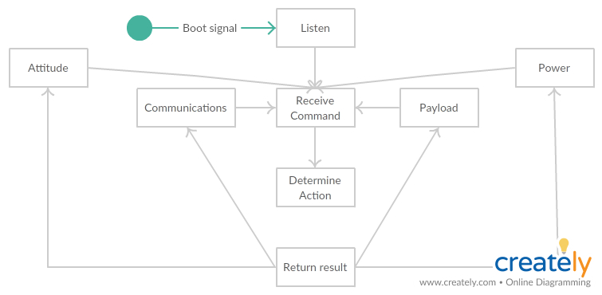

*Figure 1. State machine for the Main subsystem*

2. Attitude

Service provided to: Attitude

Description: The attitude state machine represents the attitude circuit board on CougSat I. This subsystem is meant to keep the satellite aligned in the appropriate coordinate system. As of right now, there is one coordinate system such that the face with the antenna is pointing at Earth. Once the payload board is integrated, there may be a second coordinate system such that the camera is pointing at the payload. 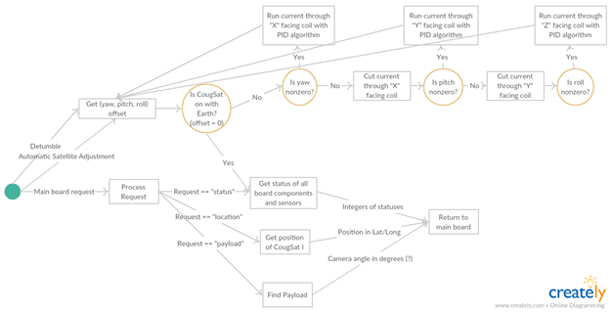

*Figure 2. State machine for the Attitude subsystem*

3. Communication

Service provided to: Communication

Description: The communication state machine represents the communication circuit board on CougSat I. The board is not available when the satellite is in Emergency mode. It is in charge of both outer and inner communication of CougSat I. The outer communication is mostly about transmissions of commands from the ground control. The inner communication indicates transmissions of information between a couple of boards inside of the satellite in order to perform the requested commands.

### 

*Figure 3. State machine for the Communication subsystem*

4. Power

Service provided to: Power

Description: The power state machine represents the power circuit board of the CougSat I. This subsystem supplies power to the electronic components on board the CougSat I. The power subsystem includes solar cells, charge controller, batteries, battery charger as well as components required for battery telemetry.

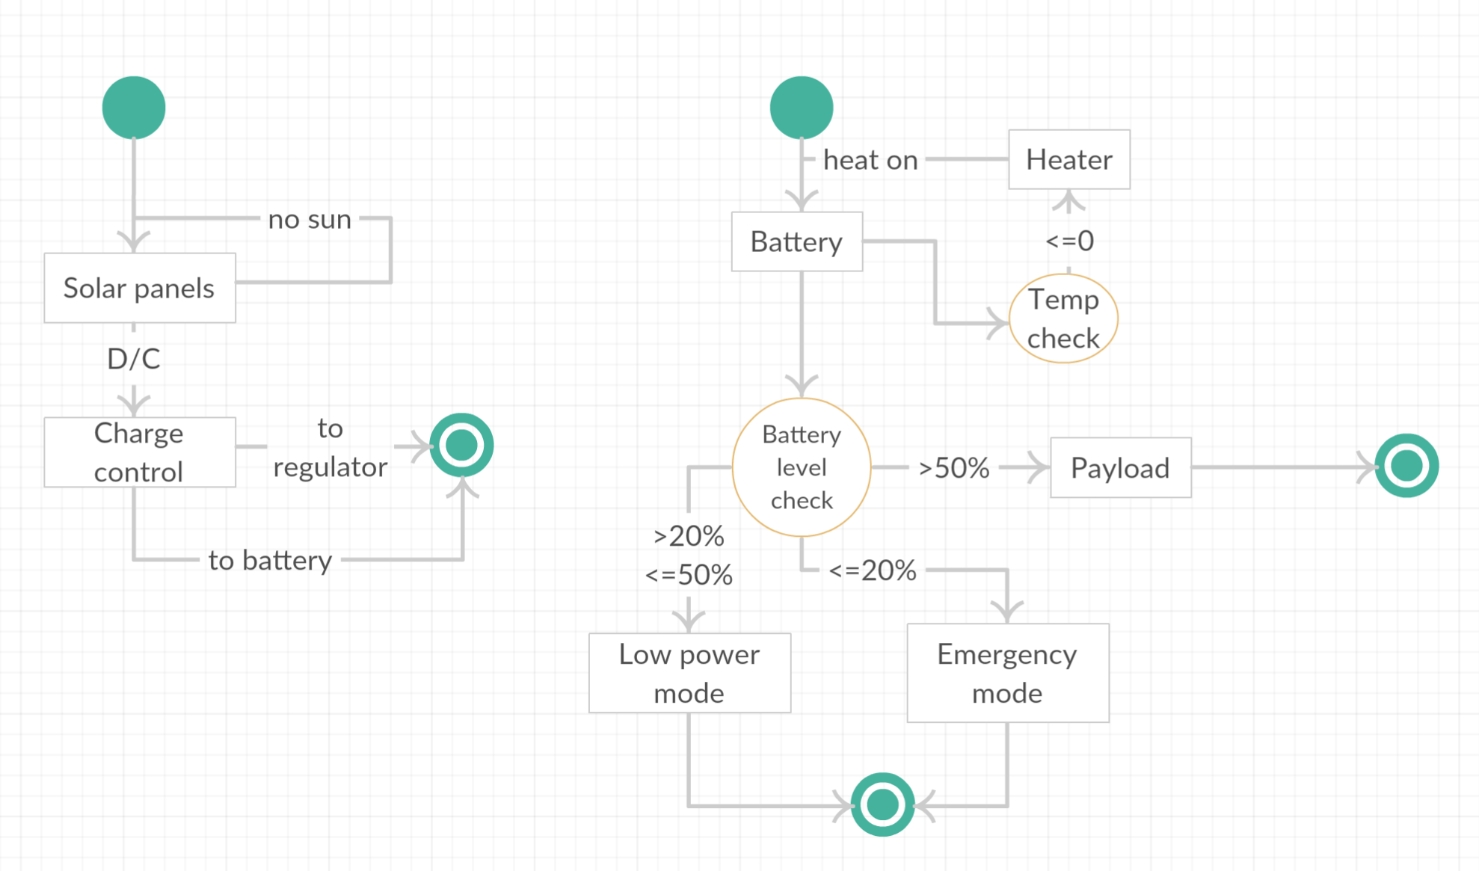

*Figure 4. State machine for the Power subsystem*

5. Payload

Service provided to: Payload

Description: This is a new addition to the satellite, and its design and behaviors are not designed yet. There is a skeleton payload state machine that is connected to Main and behaves similarly to the other boards, with the exception that the functions are not implemented.

Services Required:

The solar panel requires power from the sun to be functional as to provide power for recharging the batteries and provide power to other subsystems.

# **IV. Data design**

As of right now, we do not see a need for a database to store information sent to and received from CougSat I. With the STK report and graph manager which allows us to quickly generate reports and graph from a list of commonly used data providers. After generating the reports and graphs, there are variety of tools that allow a user to manage their data either changing the units, setting animation times, save quick reports, or save as txt, .csv files or script. When the Payload board is incorporated, a database for pictures may be something to consider.

# **V. User Interface Design**

For the simulation, the display that users will see is STK. It shows the graphic images of the simulation, which is composed of the Earth, the orbit path, the satellite, and the ground station(s).

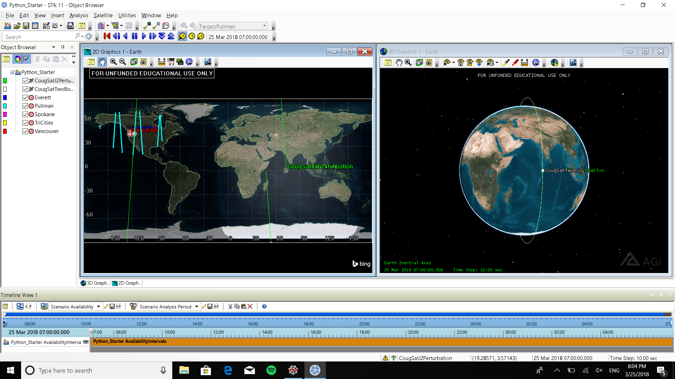

*Figure 5. STK Interface*

The main interface of the user is Python script that launches STK with all properties for CougSat I’s simulation. The script contains the process of creating new satellite and some ground stations. *Figure 6* is the image of STK launched by the script file we have now. It has five ground stations in Pullman, Spokane, Everett, Tri Cities, and Vancouver. The satellite of the current script is very basic.

As the script is not completed, we can improve it to make the satellite have its behaviors and to carry communicators between the satellite and the ground stations.

# **VI. Summary of the State of This Project**

As of the beginning of January, we have established a general state machine for the satellite as a whole as well as subsystem state machines for the attitude, communications, and power circuit boards.

Over the course of the semester, we have accomplished:

* Establishing STK as our physics engine
* Choosing Blender as our 3D creation suite
* Creating a model of CougSat I in Blender
* Integrating the CougSat I model into STK without integrating the behaviors from the ROS state machine
* Launching the satellite from different locations
* Creating a model of the ground station in Pullman, WA
* Modeling ground stations in other overlapping locations ~600 km away from Pullman, WA
* Measuring communication windows with the satellite from the ground station while the satellite is orbiting the Earth

We are currently in the early stages of integrating the ROS state machine behaviors to the CougSat I model in STK and finding a way to launch STK with a script such that it generates multiple measurements of communication windows and determines the best second ground station location based on the orbit that the satellite ends up in.

# **VII. Future Work for This Semester**

We have created a Gantt chart to organize the work for the rest of the semester. The followings are the Gantt chart, its overall timeline, and the table that the Gantt chart is based off of in order.

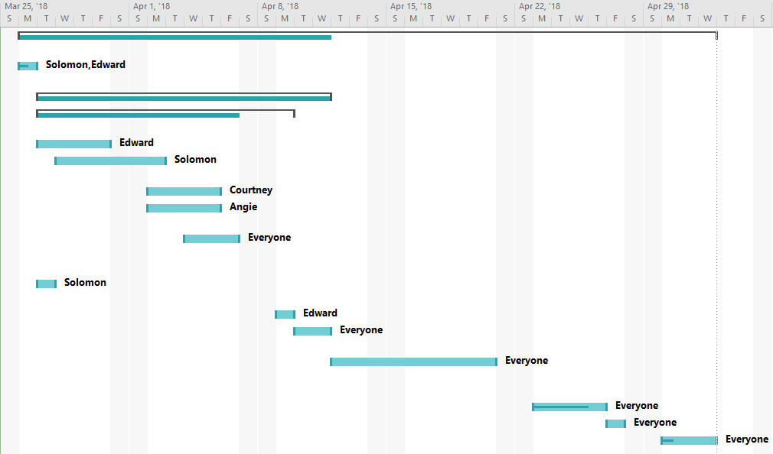

*Figure 6. Gantt chart for the timeline for the rest of the semester*

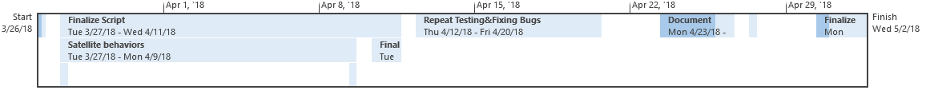

*Figure 7. Overall Timeline for the Gantt Chart*

*Figure 8. Timeline for the rest of the semester*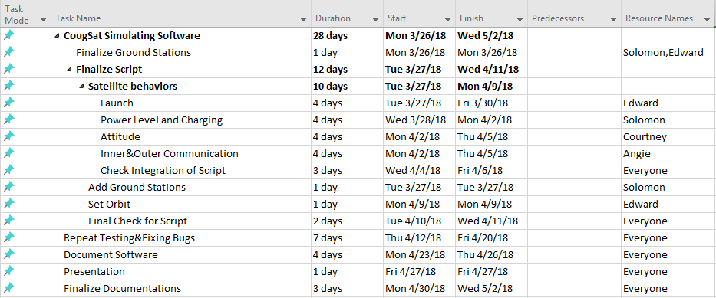

We will integrate the state machines we built for the alpha prototype of this project. The state machines are the behaviors of the circuit boards in the satellite; integrating them into the satellite requires the aforementioned script that launches STK. It is possible to integrate C# into STK, but our current state machine is in C++. We will see if our C++ state machine can be integrated into the Python script. If not, we will transcribe our state machine into Python using the Transitions state machine library.

After the state machine integration, we will determine which ground stations get the longest total access windows over the course of a simulated year. This information will help our client make the best decisions for the ground station(s) once they know what kind of orbit the satellite is in.

After these tasks are done, we have a week to test the simulator. Four days are assigned to edit and complete the documentation before the poster presentation session.

On April 27th, we will have the presentation to show CougSat I Simulation Software we have developed. Including the feedback we will get from the poster session, we will modify the software and documentation as needed.

# **VIII. Glossary**

AX.25: Amateur X.25; a data link layer that is designed for use on amateur radio packet network which has the nearly global coverage.

Blender: A 3D creation suite that supports “the entirety of the 3D pipeline—modeling, rigging, animation, simulation, rendering, compositing and motion tracking, even video editing” (Blender)

COLLADA: COLLADA documents are XML files, usually identified with a digital asset exchange (dae) filename extension

Detumble: Stop uncontrollable tumbling of a spacecraft.

GUI: Graphical User Interface; an intuitive way for users to interact with the software.

ROS: Robot Operating System; an operating system that is useful for creating state machines and simulations.

RQT: A GUI that displays the network of ROS processes that are processing data together. For our purposes, this includes nodes, messages, and topics.

Sputnik I: The first satellite launched by the Soviet Union in 1957. It transmitted electronic signals to the Earth.

STK: A physics engine that “allows engineers and scientists to perform complex analyses of ground, sea, air, and space assets, and share results in one integrated solution” (AGI).

Transitions: A lightweight, object-oriented state machine implementation in Python. Compatible with Python 2.7+ and 3.0+ (Transitions).

**IX. References**

1. AGI. “Engineering Tools.”<https://www.agi.com/products/engineering-tools>
2. Blender. “About.”<https://www.blender.org/about/>
3. Network.” *Studies in Health Technology and Informatics*, vol. 77, Feb. 2000.
4. Petrescu, Marius, and Victor Toth. “AX.25 Amateur Packet Radio as a Possible Emergency
5. Smith, K.N. “Sputnik 1 Launched The Space Race 60 Years Ago Today.” *Forbes*, Forbes Magazine. [www.forbes.com/sites/kionasmith/2017/10/04/sputnik-1-launched-the-space-race-60-years-ago-today/](http://www.forbes.com/sites/kionasmith/2017/10/04/sputnik-1-launched-the-space-race-60-years-ago-today/).
6. Transitions. “README.” <https://github.com/pytransitions/transitions/blob/master/README.md>